Hunting In Memory (Lab 2)

LAB 7.2

Scenario
The organization you work for has also asked you to perform memory threat hunting on a compromised Linux machine. As a hunting exercise to keep you sharp, the IT Security manager tasked you specifically with looking for the existence of Linux rootkits

Goals
The learning objective of this lab is to get familiar with advanced usage of Volatility.

What you will learn
You will learn how to utilize a memory dump to confirm a compromise by a rootkit.

Recommended tools
- Volatility

Tasks

Task 1. Is the system infected by Diamorhine?
Diamorphine (developed by Victor Mello) is a kernel rootkit written in C that supports Linux Kernels 2.6.x/3.x/4.x. It can hide processes, files and directories. It works by hooking the sys_call_table, more specifically it hooks the kill, getdents and getdents64 syscall handler addresses, making them point to the Diaphormine code. After loading into memory, the Loadable Kernel Module won't be visible in /proc/modules but is still visible under /sys/module.
For this task you will work against the vanilla.memory and infection1.memory memory images residing on /root/memory_dump. vanilla.memory is a memory image of the system in pristine condition.
In order to check if the system was infected by Diamorphine, leverage Volatility's linux_check_modules and linux_check_syscall plugins as well as VolShell.

Task 2. Is the system infected by Reptile?
Reptile (developed by Ighor Augusto) is a feature rich rootkit. It is written in C and under the hood it uses the Khook framework. Khook, among other things, instead of hooking the sys_call_table it uses a different technique that patches a function prologue with a JMP instruction
For this task you will work against the vanilla.memory and infection2.memory memory images residing on /root/memory_dump. vanilla.memory is a memory image of the system in pristine condition.
In order to check if the system was infected by Diamorphine, leverage Volatility's linux_hidden_modules and linux_check_inline_kernel plugins as well as VolShell.
Volatility can be found inside the /root/memory_dump directory

SOLUTIONS
Below, you can find solutions for each task. Remember though, that you can follow your own strategy, which may be different from the one explained in the following lab.

Task 1. Is the system infected by Diamorhine?
The linux_check_modules plugin looks for Loadable Kernel Modules (LKM) that are not listed under /proc/module but still appear under /sysfs/module and will output such discrepancies.
The linux_check_syscall plugin checks for modifications of the sys_call_table. All syscall handler function pointers are listed in the sys_call_table array. This plugin compares them with the address specified in the Kernel Symbols Table. In case of a mismatch, the message "hooked" is displayed.
First let's execute the below (inside /root/memory_dump) to identify all available profiles.
vol.py --info
We'll use the one depicted below.
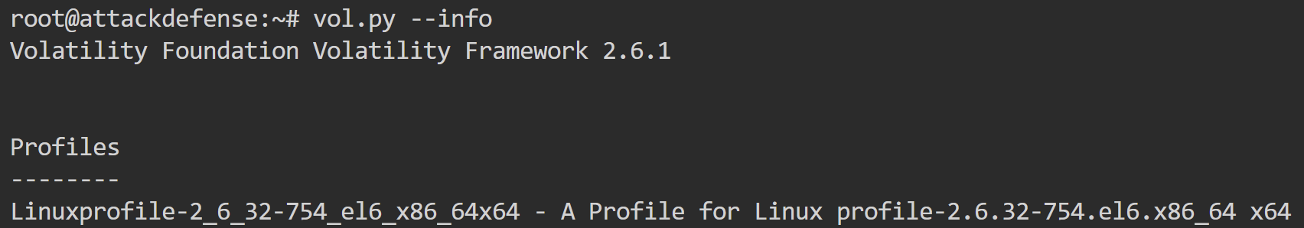
Now, let's start by executing the linux_check_modules plugin against infection1.memory.
vol.py --plugins=plugins --profile=Linuxprofile-2_6_32-754_el6_x86_64x64 linux_check_modules -f /root/memory_dump/infection1.memory
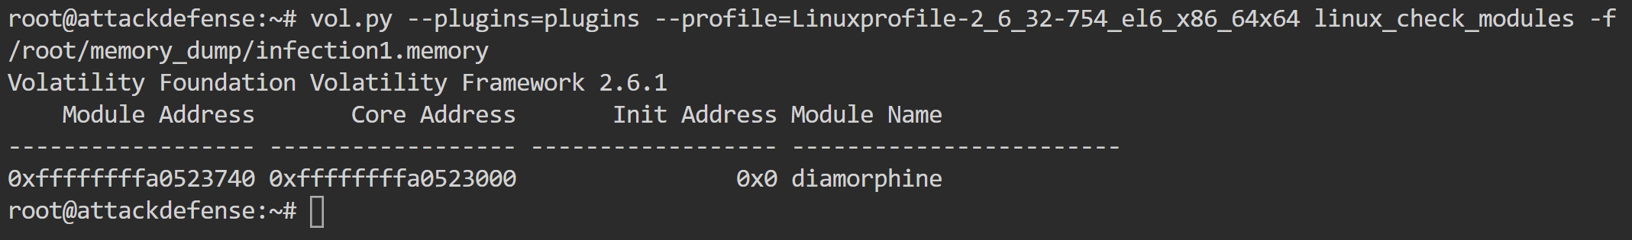
Diamorphine's module name was identified (it was still visible under /sysfs/module). Let's use VolShell to look at the first bytes of that module.
vol.py --plugins=plugins --profile=Linuxprofile-2_6_32-754_el6_x86_64x64 linux_volshell -f /root/memory_dump/infection1.memory
Then, we use the db command as follows.
>>> db(0xffffffffa0523740,128)
0xffffffffa0523740 is the module address we found with the help of linux_check_modules.
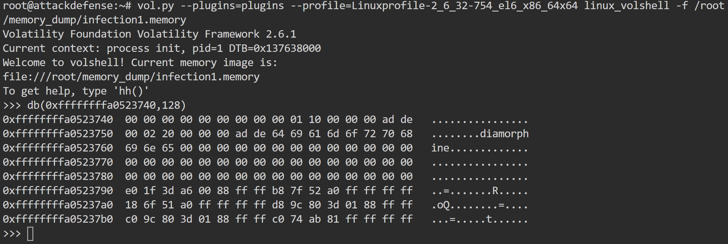
Let's now use linux_check_syscall, as follows.
vol.py --plugins=plugins --profile=Linuxprofile-2_6_32-754_el6_x86_64x64 linux_check_syscall -f /root/memory_dump/infection1.memory --output-file=linux_check_syscall.txt
cat linux_check_syscall.txt | grep -i hooked
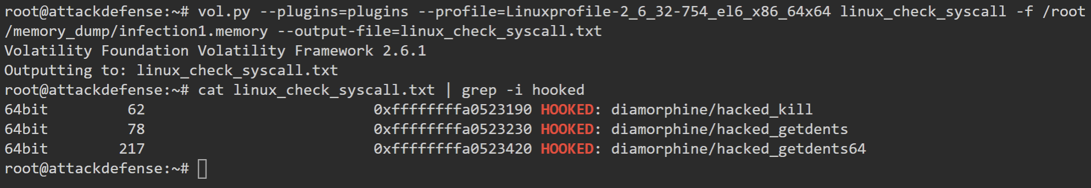
linux_check_syscall, identified three hooked syscalls (62, 78 and 217). The machine we are currently at has been disinfected, so we can check the syscall table for the abovementioned syscalls (sys_kill, sys_getdents and sys_getdents64), as follows.
cat /proc/kallsyms | grep 'sys_getdents\|sys_kill'
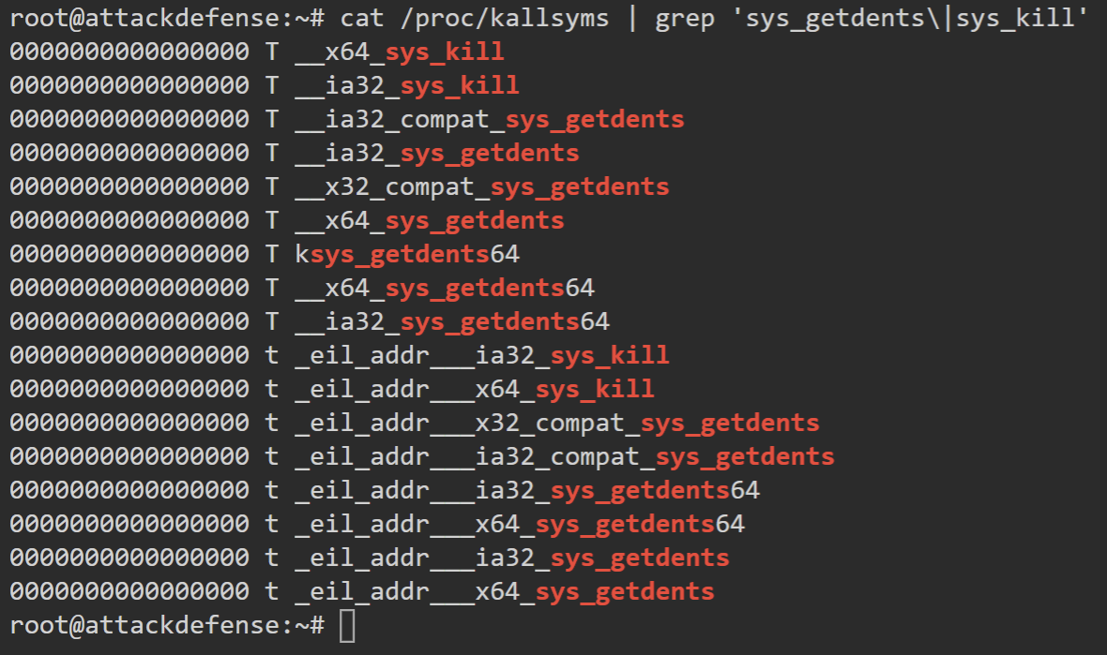
Let's look at how sys_kill looks like in the pristine system, as follows.
vol.py --plugins=plugins --profile=Linuxprofile-2_6_32-754_el6_x86_64x64 linux_volshell -f /root/memory_dump/vanilla.memory
Then, we use the dis command as follows.
dis(0xffffffff81098d20,length=45)
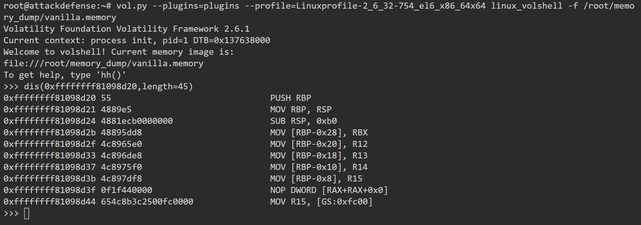
This is how sys_kill looks like in the pristine system.
Let's now look at how sys_kill looks like in the infected system, as follows.
vol.py --plugins=plugins --profile=Linuxprofile-2_6_32-754_el6_x86_64x64 linux_volshell -f /root/memory_dump/infection1.memory
Then, we use the dis command as follows.
dis(0xffffffffa0523190,length=45)
0xffffffffa0523190 is the first hooked syscall (sys_kill) that linux_check_syscall identified.
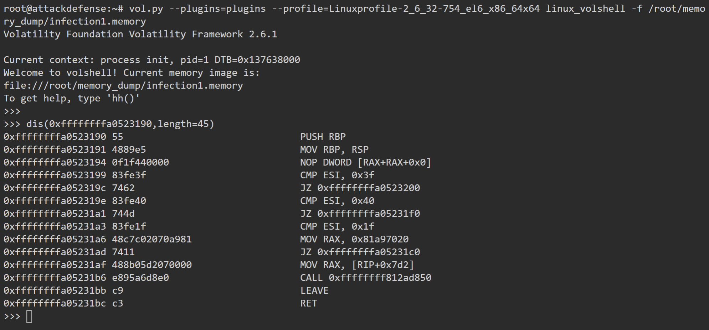
This is how the hooked sys_kill syscall looks like (in the infected system).
By comparing how the two sycalls (sys_kill in the pristine system and sys_kill in the infected system) you can see how a hook looks like!

Task 2. Is the system infected by Reptile?
This time we will use the linux_hidden_modules plugin. The linux_check_syscal plugin can't detect the hooking technique being employed by the Reptile rootkit (since the syscall handler addresses have not been modified).
Among other things, Reptile hooks fillonedir(), filldir(), filldir64(), compat_fillonedir(), compat_filldir(), compat_filldir64(), __d_lookup(). To hide processes, it hooks tgid_iter() and next_tgid(). To hide network connections, it hooks tcp4_seq_show and udp4_seq_show.
vol.py --plugins=plugins --profile=Linuxprofile-2_6_32-754_el6_x86_64x64 linux_hidden_modules -f /root/memory_dump/infection2.memory
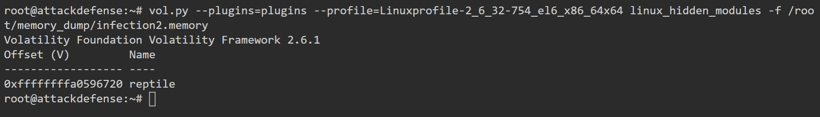
The Reptile rootkit hidden module was uncovered by the linux_hidden_modules plugin.
Now, let's also check the linux_check_inline_kernel plugin. This plugin detects inline hooking. Among other things it checks if the prologue of specific functions in the kernel contains assembly instructions like JMP, CALL or RET and warns the analyst of any functions being hooked.
vol.py --plugins=plugins --profile=Linuxprofile-2_6_32-754_el6_x86_64x64 linux_check_inline_kernel -f /root/memory_dump/infection2.memory
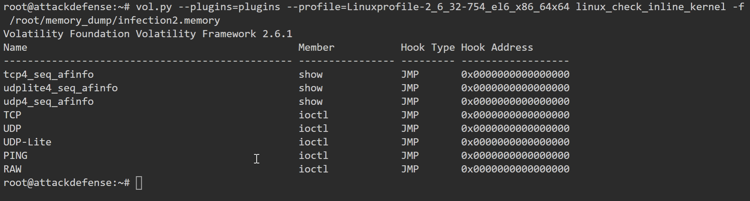
The plugin detected several network-related functions that were patched by the Reptile rootkit.
Let's use VolShell again against both vanilla.memory and infection2.memory to see how a hooked function(tcp4_seq_show) looks like.
vol.py --plugins=plugins --profile=Linuxprofile-2_6_32-754_el6_x86_64x64 linux_volshell -f /root/memory_dump/vanilla.memory
Then, we use the dis command as follows.
dis(addrspace().profile.get_symbol("tcp4_seq_show"),length=11)
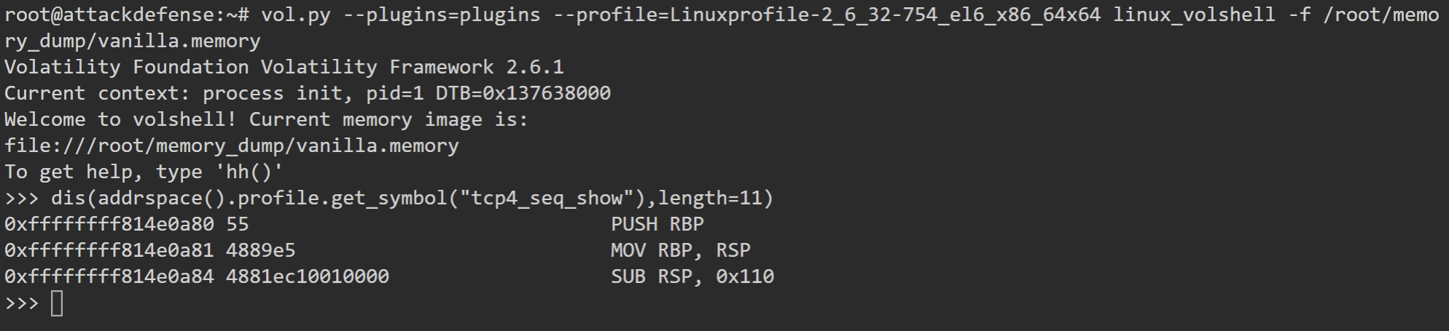
This is how tcp4_seq_show looks like in the pristine system.
vol.py --plugins=plugins --profile=Linuxprofile-2_6_32-754_el6_x86_64x64 linux_volshell -f /root/memory_dump/infection2.memory
Then, we use the dis command as follows.
dis(addrspace().profile.get_symbol("tcp4_seq_show"),length=11)
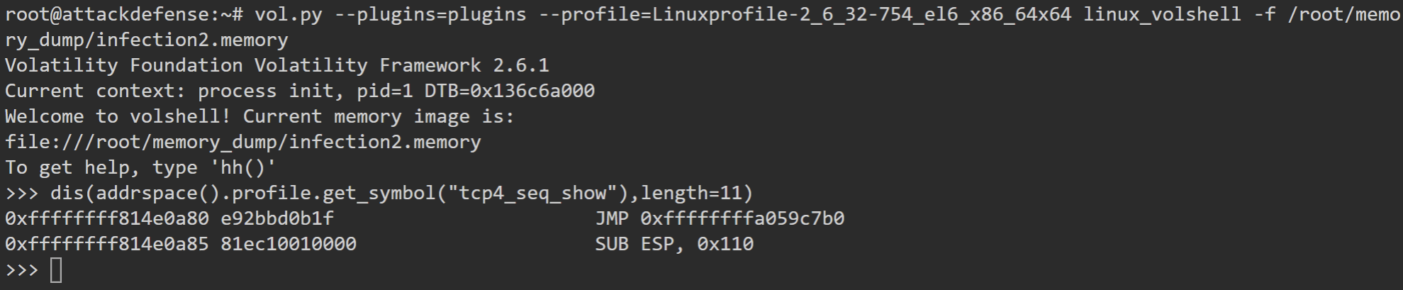
This is how tcp4_seq_show looks like in the infected system. It has been patched to jump (JMP) to the Reptile code.
Note: In order to hide directories Reptile also patches the fillonedir function. Volatility didn't detect this!
vol.py --plugins=plugins --profile=Linuxprofile-2_6_32-754_el6_x86_64x64 linux_volshell -f /root/memory_dump/vanilla.memory
Then, we use the dis command as follows.
dis(addrspace().profile.get_symbol("fillonedir"),length=11)
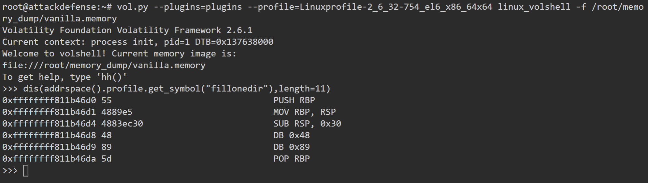
This is how fillonedir looks like in the pristine system.
vol.py --plugins=plugins --profile=Linuxprofile-2_6_32-754_el6_x86_64x64 linux_volshell -f /root/memory_dump/infection2.memory
Then, we use the dis command as follows.
dis(addrspace().profile.get_symbol("fillonedir"),length=11)
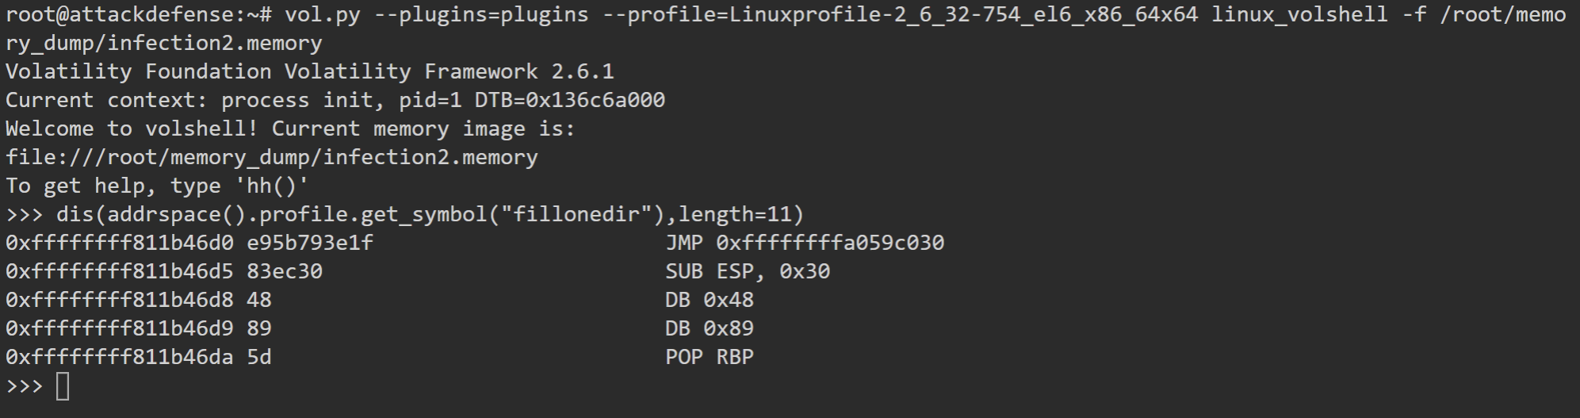
This is how fillonedir looks like in the infected system. It has been patched to jump (JMP) to the Reptile code.

References:
- http://www.dfir.org/research/android-memory-analysis-DI.pdf
- https://www.youtube.com/watch?v=oWkOyphlmM8
- https://github.com/504ensicsLabs/LiME
- https://www.blackhat.com/presentations/bh-dc-07/Walters/Paper/bh-dc-07-Walters-WP.pdf
- http://4tphi.net/fatkit/papers/fatkit_journal.pdf
- http://volatilesystems.blogspot.com/2008/08/pyflagvolatility-team-wins-dfrws.html
- http://dfir.org/research/omfw.pdf
- https://github.com/halpomeranz/lmg
- https://nvlpubs.nist.gov/nistpubs/SpecialPublications/NIST.SP.800-61r2.pdf
- https://github.com/volatilityfoundation/volatility/wiki/Linux-Command-Reference
- https://github.com/m0nad/Diamorphine
- https://github.com/f0rb1dd3n/Reptile/
- https://github.com/h2hconference/2018/
- https://countuponsecurity.com/2019/10/14/notes-on-linux-memory-analysis-lime-volatility-and-lkms/

